Market Monitor - Somalia - 2026-05

Highlights
Food prices continued their upward trend in May 2026, with increases observed across all monitored commodities, further straining household purchasing power. The national average cost of the food basket increased to SOS 493,383.09, marking a month-over-month rise of 6.9% (↑) and a year-over-year increase of 22.1% (↑). Price hikes were most pronounced for imported rice (↑11.4% MoM; ↑37.8% YoY), cowpeas (↑8.9% MoM; ↑30.0% YoY), and white sorghum (↑7.7% MoM; ↑14.3% YoY).
Key Drivers:
- Widespread monthly price increases were recorded across all food commodities in the basket.
- Significant inflation in imported staples, with rice prices surging by a notable 11.4% during the month.
- Sharp price increases for locally produced staples, particularly cowpeas (↑8.9%) and sorghum (↑7.7%).
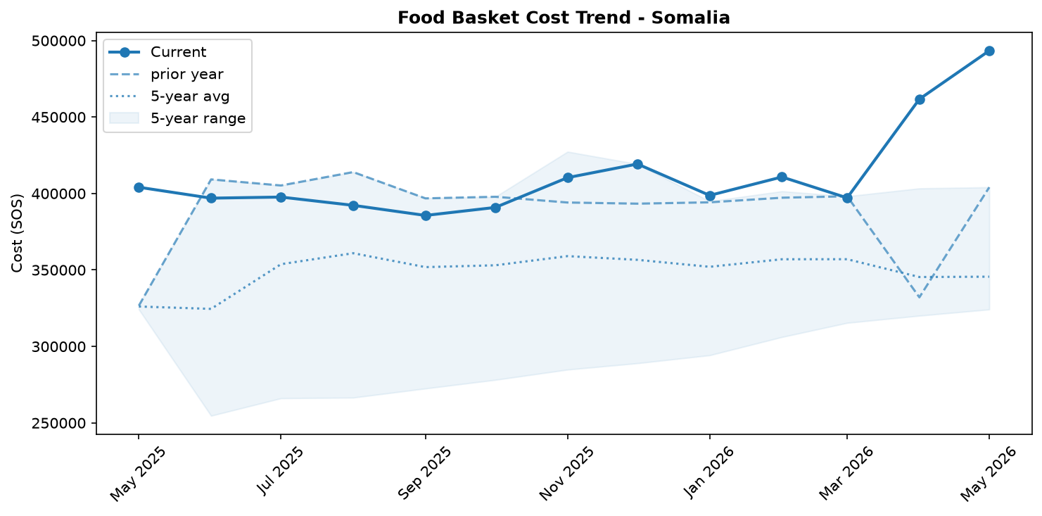
Food basket cost trend

Market Overview
Market conditions in Somalia deteriorated significantly in May 2026, characterized by widespread and accelerating price increases across all monitored food staples. The national average cost of the food basket surged by 6.9% month-on-month and a substantial 22.1% year-on-year, severely constraining household purchasing power. The upward price trajectory was driven by broad-based inflation, with particularly sharp hikes observed for key imported staples like rice and locally sourced cowpeas. This trend is especially alarming as it occurs against a backdrop of deepening humanitarian concern. Recent analyses confirm a credible risk of famine in areas such as Burhakaba District and a nationwide increase in admissions for severe malnutrition. Notably, these inflationary pressures are not driven by currency depreciation, as the Somali Shilling remained stable against the US dollar. This stability suggests that other factors, such as supply chain disruptions, poor local harvests, or rising global commodity costs, are fueling the price hikes. Given the persistent monthly increases, food affordability is expected to worsen in the short term, exacerbating the fragility and food insecurity challenges highlighted in recent reports.

Commodity Analysis
An analysis of individual commodity prices reveals a universal upward trend in May, with all seven components of the food basket recording both monthly and yearly increases. Imported rice experienced the most dramatic surge, climbing 11.4% from April and a staggering 37.8% compared to the previous year, underscoring the significant inflationary pressure on this essential import. Cowpeas also saw a major price hike, rising 8.9% month-on-month and 30.0% year-on-year. Prices for locally produced cereals continued to climb, with white maize and white sorghum increasing by 5.3% and 7.7% respectively over the month. On a year-on-year basis, maize prices are up 25.2%, reflecting significant long-term pressure on this staple. Other key imports also became more expensive. The price of vegetable oil rose 4.5% month-on-month (21.3% year-on-year), and sugar increased by 5.5% (9.5% year-on-year). Imported wheat flour recorded the mildest monthly increase at 1.5%, but its 10.3% year-on-year rise is still a significant burden for consumers. The comprehensive nature of these price increases across both local and imported goods points to systemic stress on food supply and access throughout the country.
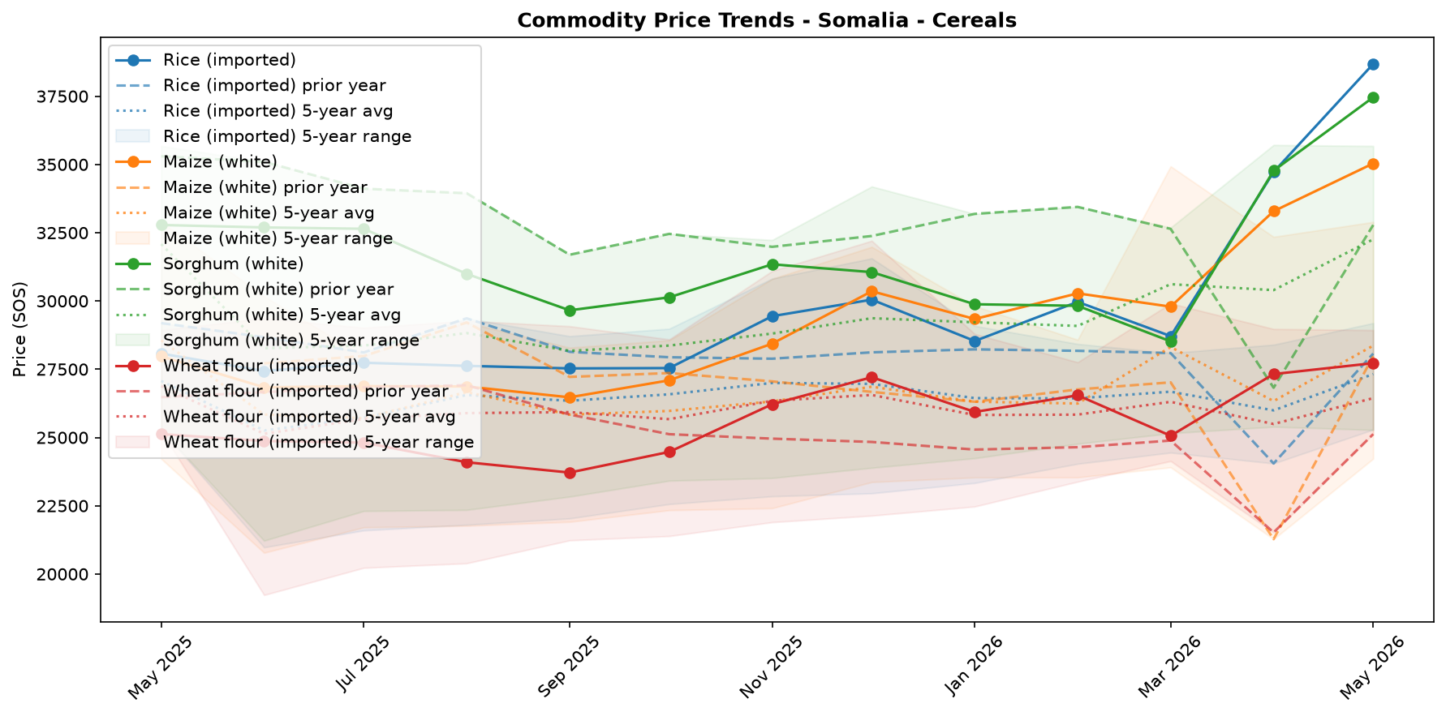
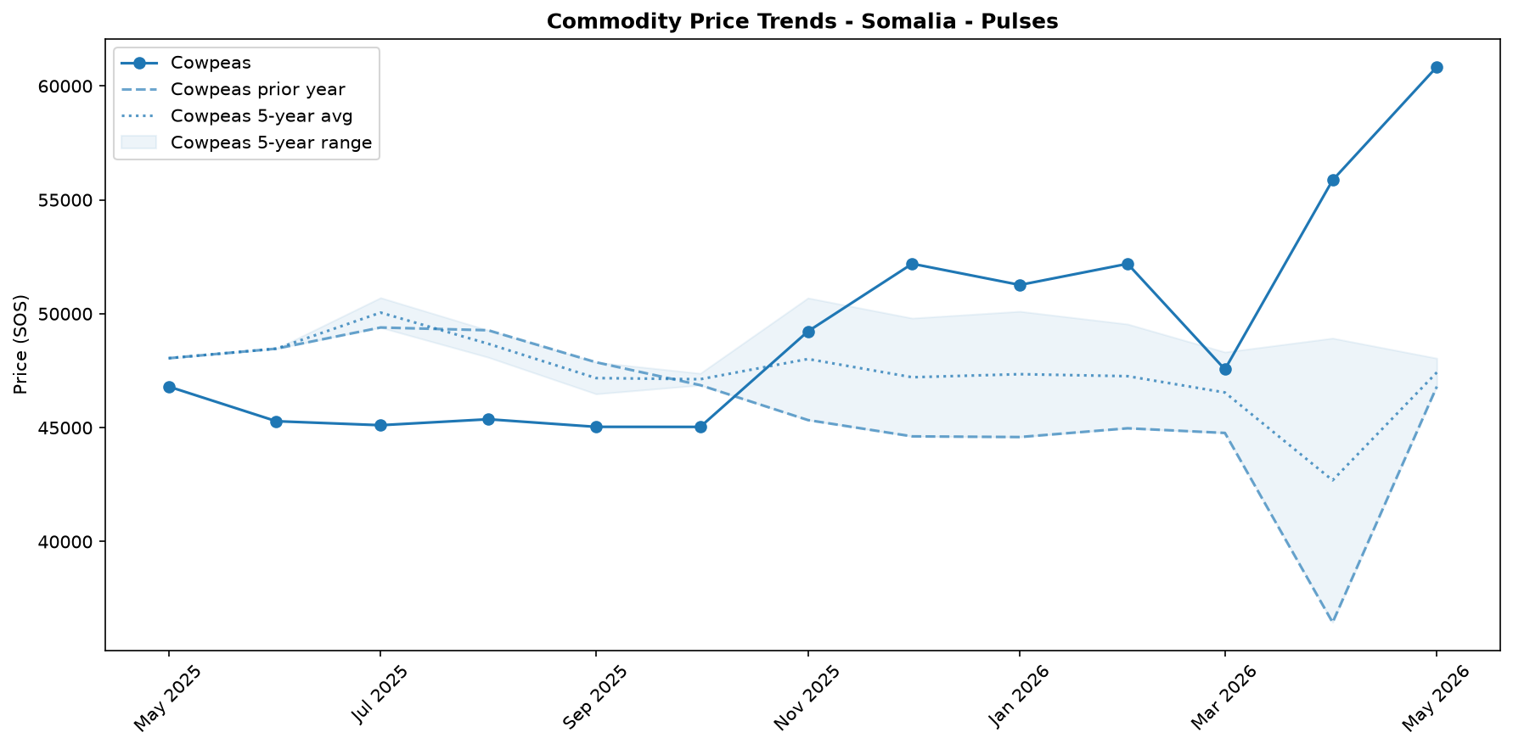
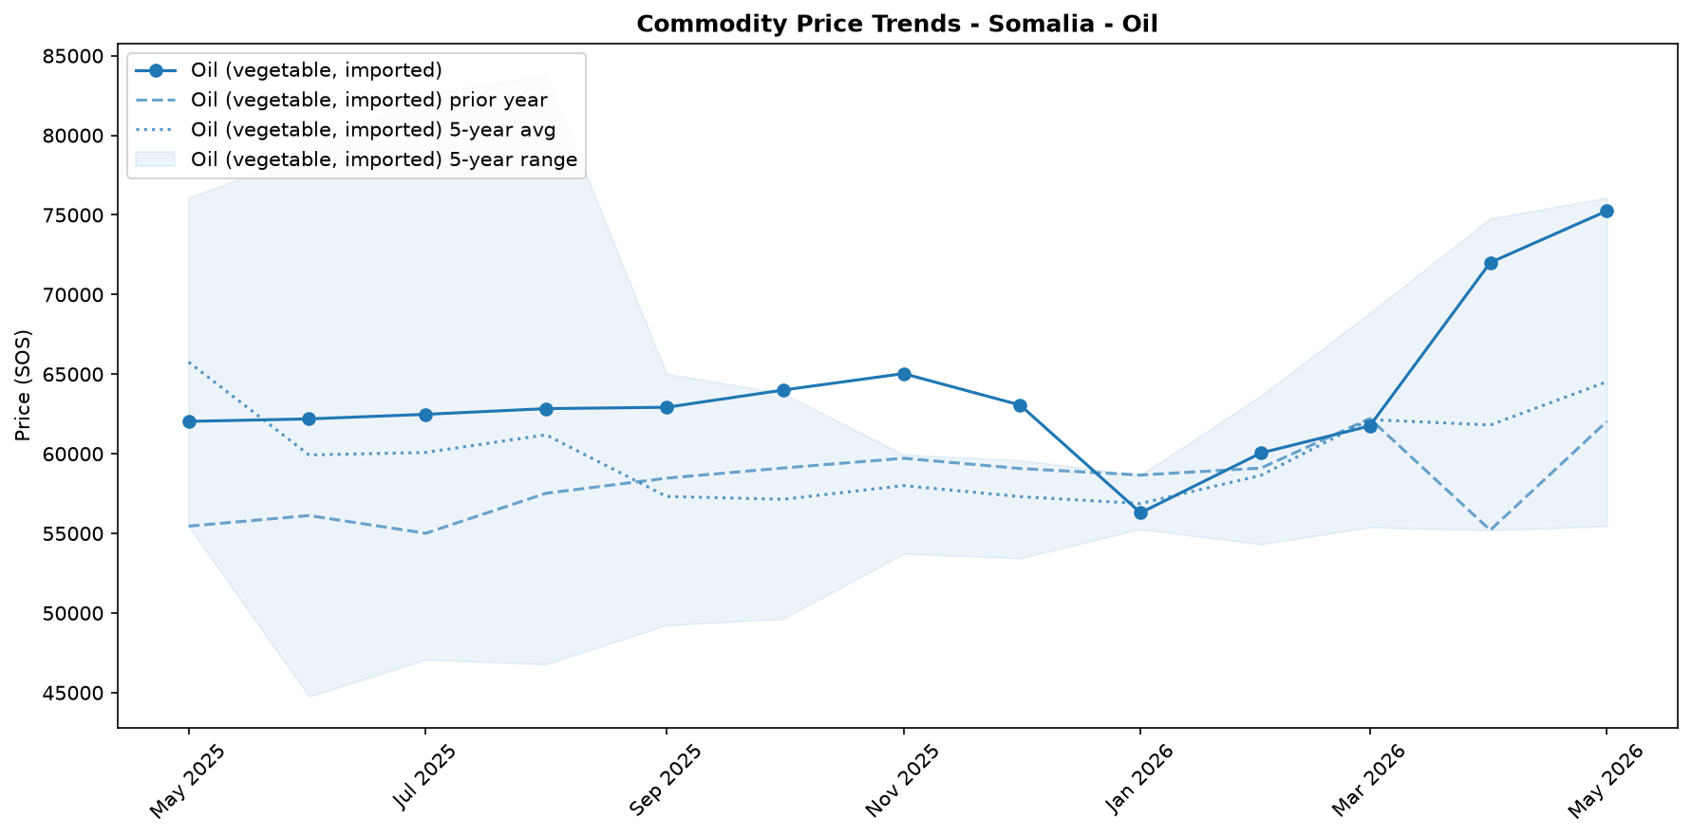
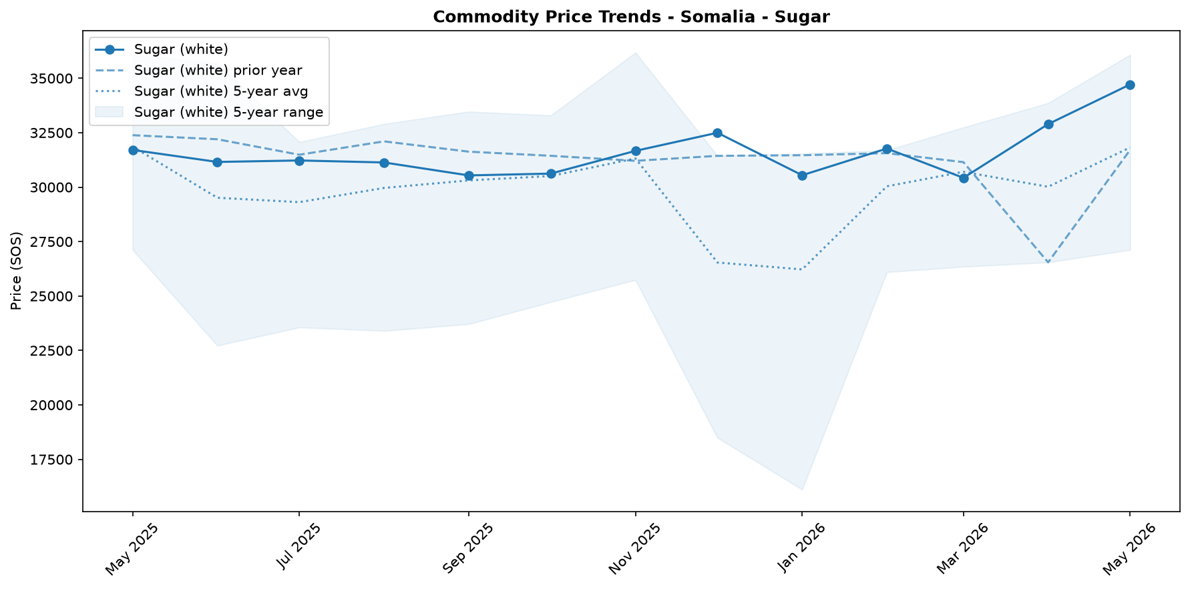

Regional Highlights
While the available data reflects a national trend of rising food prices, the severe consequences are most visible in specific vulnerable regions. The 6.9% national monthly increase in the food basket cost is placing immense pressure on communities already facing acute food insecurity. For instance, a recent Integrated Food Security Phase Classification (IPC) analysis for Burhakaba District in the Bay Region revealed a rapidly worsening situation and a credible risk of Famine (IPC Phase 5). This localized crisis is consistent with the pressures created by the significant, nationwide price hikes of essential staples. Further evidence of deteriorating conditions at a sub-national level comes from humanitarian partners like Action Against Hunger, which has witnessed a significant rise in admissions of severely malnourished children to its stabilization centers across the country. In contrast, a recent study demonstrated the positive impact of multi-purpose cash assistance (MPCA), which dramatically improved household food consumption scores, highlighting a critical tool to mitigate the impact of soaring prices in the most affected areas.
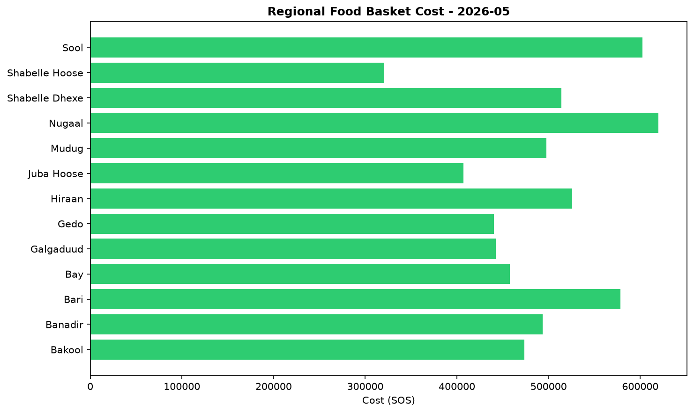

EXCHANGE_RATE Analysis
The Somali Shilling (SOS) remained stable against the US dollar, trading at 571.5 SOS per USD. The exchange rate recorded no change month-on-month (0.0%), which helps to prevent an increase in the cost of imported goods and provides a predictable environment for traders. Similarly, the currency showed no change compared to the same period last year (0.0% year-on-year), indicating a sustained period of stability and a flat long-term trajectory. This continued stability is crucial for containing imported inflation, as it helps to moderate upward pressure on the local prices of essential imported commodities. This is particularly important for key food items like wheat, rice, and cooking oil, as well as fuel, thereby supporting the purchasing power of vulnerable households who rely heavily on these goods.

References
- [rw_4214041] ReliefWeb (2026-05-29) Somali Cash Consortium – Baseline and Endline Findings MPCA Outcomes from the Direct Nutrition Referral Approach: Gedo & Banadir regions, Somalia (November 2025)
https://reliefweb.int/node/4214041
- [rw_4213907] ReliefWeb (2026-05-28) Somalia: Emergency and Resilience Plan, 2026–2028
https://reliefweb.int/node/4213907
- [rw_4213862] ReliefWeb (2026-05-28) World Hunger Day: Urgent global action needed as hunger doubles in a decade
https://reliefweb.int/node/4213862
- [rw_4213744] ReliefWeb (2026-05-26) Somalia Faces Deepening Hunger Crisis as Risk of Famine Emerges in Burhakaba
https://reliefweb.int/node/4213744
- [rw_4213683] ReliefWeb (2026-05-26) Somalia: Diphtheria Outbreak - DREF Final Report (MDRSO024)
https://reliefweb.int/node/4213683
- [rw_4213549] ReliefWeb (2026-05-25) WFP Somalia Country Brief May 2026
https://reliefweb.int/node/4213549
- [rw_4213533] ReliefWeb (2026-05-25) Sexual Exploitation and Abuse (SEA) Joint Risk Assessment for Somalia - February 2025
https://reliefweb.int/node/4213533
- [rw_4213456] ReliefWeb (2026-05-25) Somalia Weekly Weather Forecast - Valid From 21 to 27 May 2026
https://reliefweb.int/node/4213456
- [rw_4213396] ReliefWeb (2026-05-24) Somalia - ARC Drought Insurance Payout Activation Bulletin: 2025–26 Deyr Season (May 2026)
https://reliefweb.int/node/4213396
- [rw_4213288] ReliefWeb (2026-05-22) Radio Ergo Weekly Feedback Report, Issued: 22 May 2026
https://reliefweb.int/node/4213288
- [seerist_1028776] Seerist (2026-05-29) Global maritime outlook: June 2026
- [seerist_1028721] Seerist (2026-05-27) Big Picture series: Carbon markets in Sub-Saharan Africa – growing opportunities amid regulatory, integrity challenges
- [seerist_1028607] Seerist (2026-05-19) Big Picture series: France’s push into anglophone Africa to bring new commercial opportunities despite West African controversies
- [seerist_1028580] Seerist (2026-05-18) Substantial ransoms to remain feature of Somali piracy following reported USD 10m demand
- [seerist_1028391] Seerist (2026-04-30) Global maritime outlook: May 2026
- [seerist_1028308] Seerist (2026-04-24) Local resistance, external pressure likely to undermine federal push to remove Jubaland administration
- [seerist_1028144] Seerist (2026-04-14) Big Picture series: Strait of Hormuz disruption to drive acute fiscal, supply chain challenges in Africa

